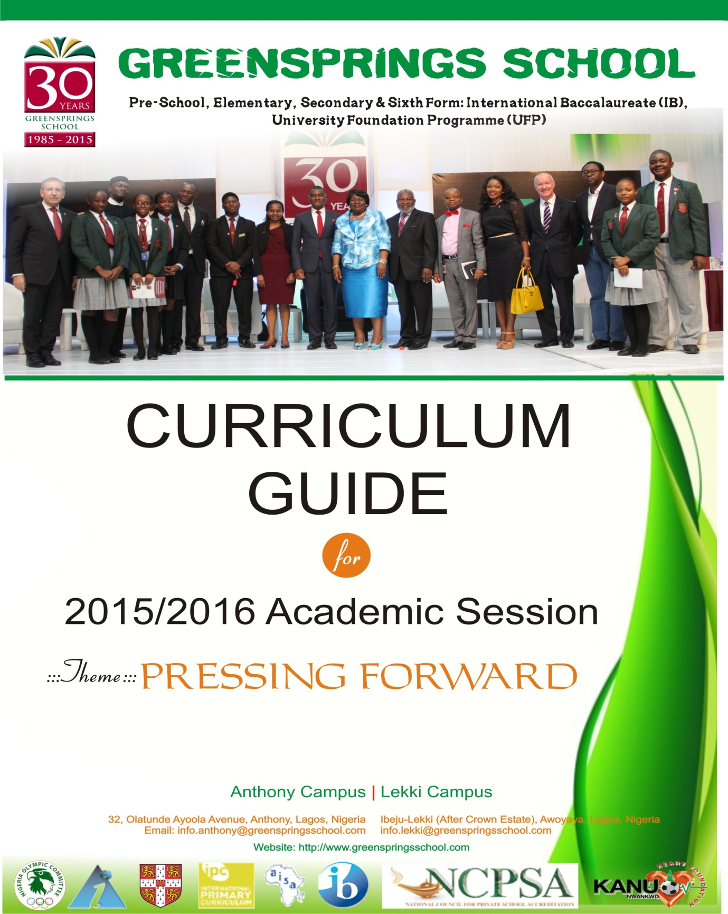

IB 1 MATHEMATICS (STANDARD LEVEL)

|  |  |
| --- | --- |
| Algebra | Linear, quadratic, simultaneous, binomial theorem, disguised equations |
| Algebra | Sequences, series ,word problems |
| Algebra | Logarithm and exponents |
| Functions | Mapping, composite, inverse, graphs, transformations of functions |
| Circular functions | Length of arc, area of sector |

|  |  |
| --- | --- |
| Trigonometry | Identities,compound angle identities, trigonometry equations, |
| Calculus 1 | Derivative of simple algebra, polynomials |
| Calculus 2 | Sum and product rule |
| Calculus 3 | Derivative of exponential and logarithm functions |
| Calculus 4 | Derivative of trigonometry, applications, tangents and normals |
| Calculus 5 | Maximum and minimum, point of inflexion, curve sketching, second differential, rate of change |
| Calculus 6 | Integration, rate of change,applications |
| Calculus 7 | Applications , areas and volume of revolution |